Creating a Model And Pattern Classification for Adult Census Data

Data Set(s) *:*Adult

Amirhossein Forouzani, amirhosf@usc.edu

April 25, 2019

# Abstract

As part of the final project in Mathematical Pattern Classification course, this research would explore different classification techniques throughout the course to find the best classification model for Adult Data set. The goal of the adult data set is to design the best model that would predict if the income of a certain person is more than $50k based on many factors including education, country etc. The data examination showed that adult data is a categorical data set with distributions. This indicates that the data should be encoded using 0s and 1s instead just their numbers. After feature reduction using select from model algorithm the data set (Small Data Set) was then subjected to different classification techniques including, Perceptron using one versus rest classifier, Logistic regression with Random Embedded trees and Random Forest, SVM(Support vector machines) using radial basis Kernel, Multinomial Naïve Bayes Classifier and finally Artificial Neural Network (ANN) with 2D hidden layer of 15 by 2 using multi-layer perceptron (MLP). The most accurate classification is Logistic Regression with ensemble of trees using random Forest Classifier with accuracy of 86%-f1 score of 0.64 and AUC area of 0.9.

# Introduction

# Problem Statement and Goals

The Adult Data set is a two-class classifier problem. The goal is to tell if a person makes more than or less than $50k annually. This indicates that we can use binary classifier techniques to tackle this problem. Preprocessing is the first and most important step of analyzing the data. The right type of encoding has to be used for categorical features. The classifier has to be carefully picked according to number of classes.

# Approach and Implementation

## 3.0. Importing Data

To Import the file, I used pandas readcsv function. This function allows parsing through data easily and saving file to data frames. The data was already divided to data frames f1-f14, after reading the original file on the UC Irvine dataset, I decided to change the header names to respectable names. This is merely done to help with reading the data information for future preprocessing.

## Analyzing the Distribution and the correlation of the data

Firstly, I drew a complete table of feature’s distribution with respect to the classifier, which is whether someone makes more than $50k or not.

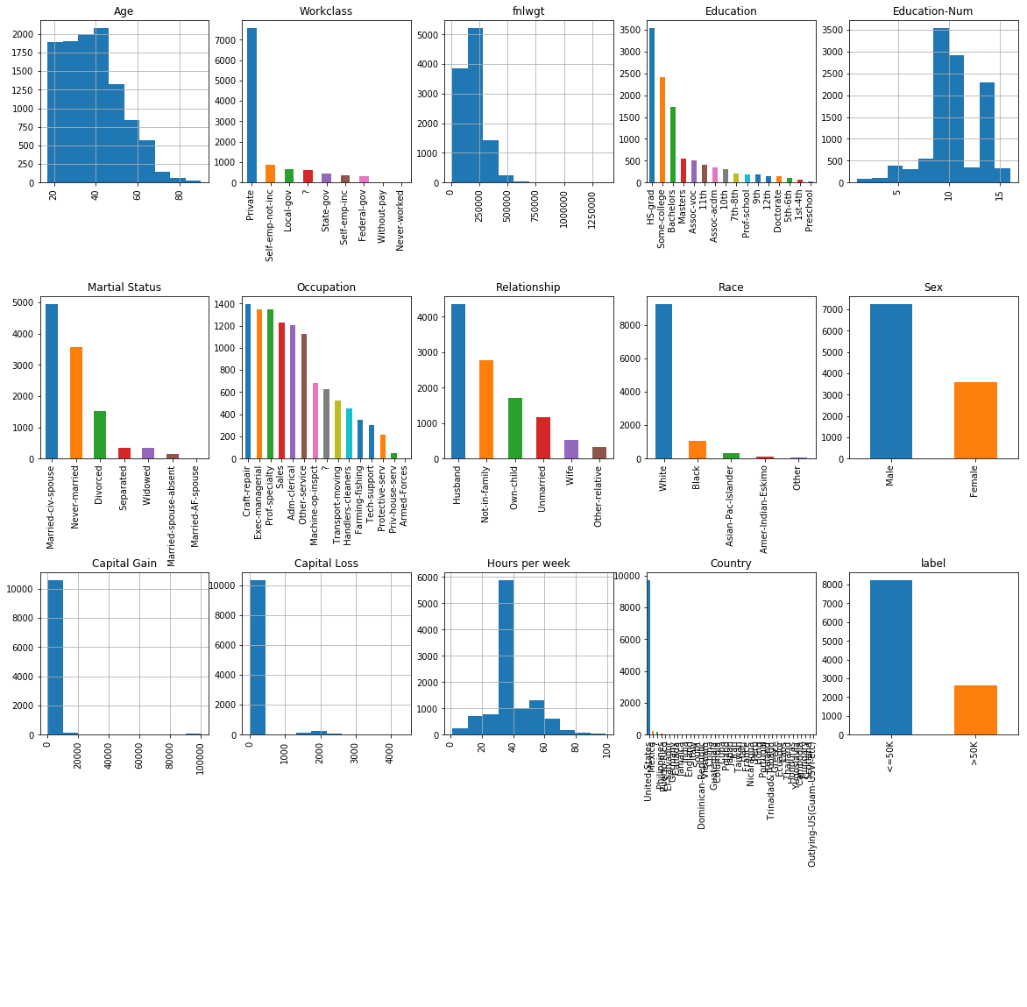The resulting distribution table is as follows.

Figure 1. Showing the Distribution of the data

As can be seen in figure 1 the number analyzed people are mostly residing in America. We will use this later in preprocessing the data.

Next we need to find the correlation between features on the data

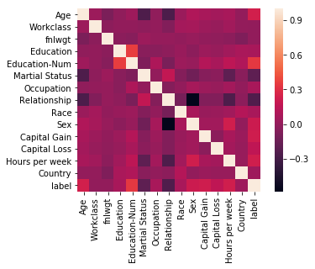

Figure 2. The correlation heatmap of the Data

As can be seen in the data there is a high correlation between the Education and Education Number. There is also high correlation between sex and marriage columns this can help us in the feature reduction later on.

## Preprocessing

In this section various techniques are done to prepare and preprocess data.

### 3.2.1 Encoding

The variables come in categorical names and string. I needed to come up way to only represent all the categories with numbers so it will be easier for the program to analyze them. The first approach is to use the encode function of the sklearn[3][2]. This would only change the categorical features to numbers. While this might be a good way to encode the data, we would later see that this is not the best method to encode the categorical features with correlation. The following figure shows the distribution of the data after encoding.

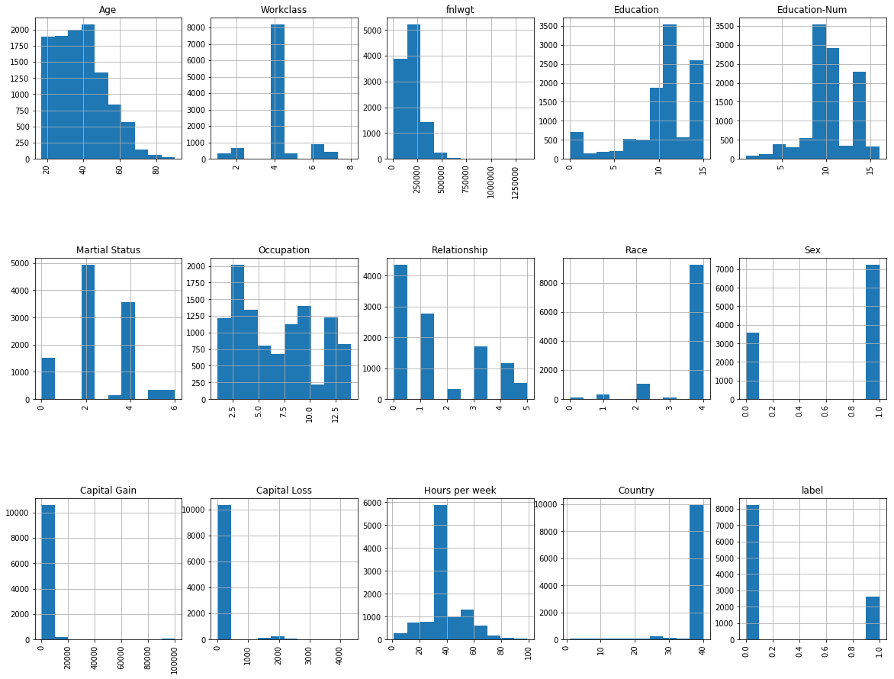

Figure 3. The Picture shows both Imputed and Encoded data Set.

Looking at the Label table we can see that we are dealing with an unbalanced dataset meaning that we have too much of a first class compare to another one. We would later fix this by resampling the data.

### 3.2.2 Imputing

Some of the features in the adult data are indicated as “?“. To fix this the data needs to be imputed so the feature would be filled. To do this I defined a class called impute categorical that uses the in-built sklearn sklearn function impute. I set the rules so the data would be imputed using the most frequent approach.

### 3.2.3 Scaling

Finally, to make the data more processable I scaled the data between [-1,1] using sklearn scale function.

## Compensation for unbalanced data [3]

As I explained in the previous section the data is imbalanced and we have to much of a one class. Firstly, to analyze the accuracy of our classifiers we need to use f1 score instead of the accuracy score.

Moreover, to tackle imbalanced data I used under sampling technique. This would resample the training data and remove any data that would make one class more than the other. This method would, for every observation of class 0, randomly sample from class 1 without replacement and then join together class 0’s target vector with the down sampled class 1 targets. In scklearn it is defined as ﻿resamplingdata_downsample(X,y).

## Feature extraction and dimensionality adjustment

As explained in the first section, the data has two features that are high correlated. We can remove these to reduce the dimensionality of the feature space. I also used ‘select feature from classification‘model to reduce the number of the features in the data. This feature selector would reduce feature space based on the linear SVC modeling. As a result, I got rid of 2 features and was working with 12 out of 14.

## Dataset Usage

Using the training set and test set as is, is not going to be helpful because we are handling unfairly distributed data. As I will show in the result sections, just using the test and train set are not going to provide a model with good ROC(Receiver Operation Characteristic)[3][4] curve. Train and test_split functions were used alongside with tree expansion functions like “random forest” to increase the dimensionality of the data first then running it through a pipeline for classification to achieve a better model and classifier. I will Later explain this in the appropriate section. For cross validation I divided the training set to 50% test and 50% train. It is important to train the ensemble of trees (for embedded trees and random forest) on a different subset of the training data than the linear regression model to avoid overfitting, in particular if the total number of leaves is similar to the number of training samples. As a result the test and train were split twice.

## 3.5.1 Performance Evaluation Techniques

ROC curve is used to test performance of a classifier by plotting false positive rate verses true positive rate. The larger AUC, the better classification result.

$$Recall=\frac{TP}{TP+FN}$$

$$Percision=\frac{TP}{TP+FP}$$

F1 score which calculated by $2×\frac{precision×recall}{precision+recall}$ is also used to imply classification result. 0.5 is the most optimal F1 score. While it is the most optimal it can not really indicate the best clasiifier. A combination of Recall, Persision, Accuracy and ROC (Receiver Operating Characteristic) should be uaed to determine the best model.

## 3.5.2 Overall Implementation

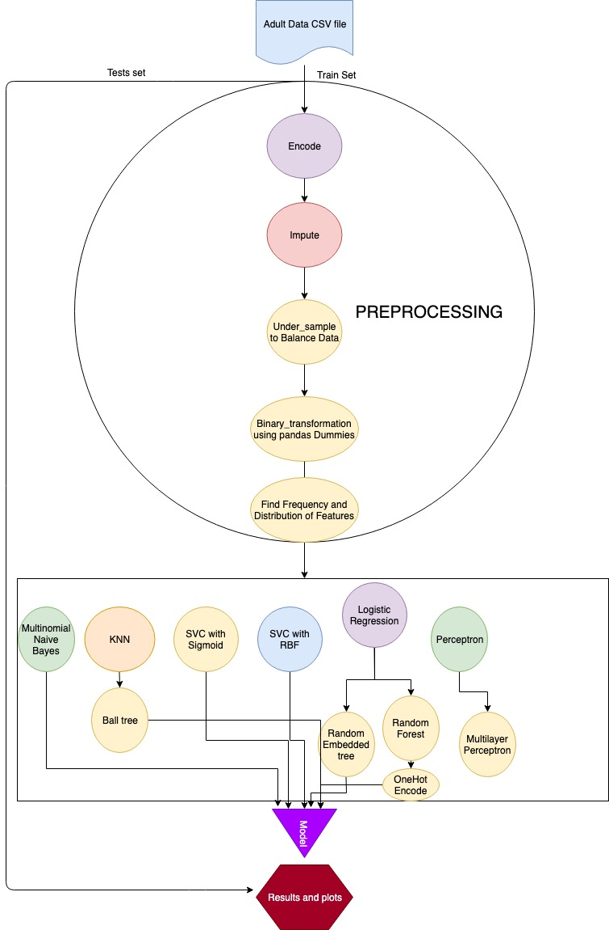

## Training and Classification

1. The first, suitable classifier I used for this data was ***logistic regression***. There are some differences between linear regression and logistic linear regression. In linear regression, the outcome (dependent variable) is continuous. It can have any one of an infinite number of possible values. In logistic regression, the outcome (dependent variable) has only a limited number of possible values. This will widely help us classify the distributed features.

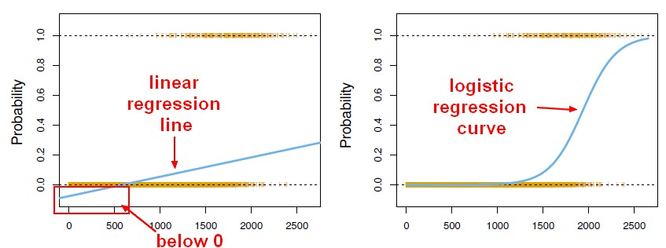

The formula is similar to linear regression with different parameters.

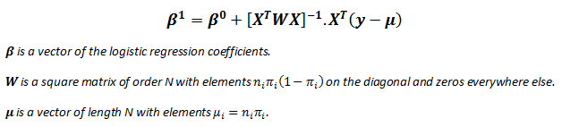

$$p = p(X) = S(X^{T}β)=\frac{1}{1+e^{-X^{T}β}}$$

We are still defining a coefficient by which the regressor is going to converge. In this method I used the lbfg( Ridge regression) method. In Ridge Regressor the data might lead to under fitting but because we are using many iterations of the data set, we can avoid under fitting while not facing overfitting. The criterion of the Logistic regressor is as follows:

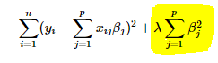

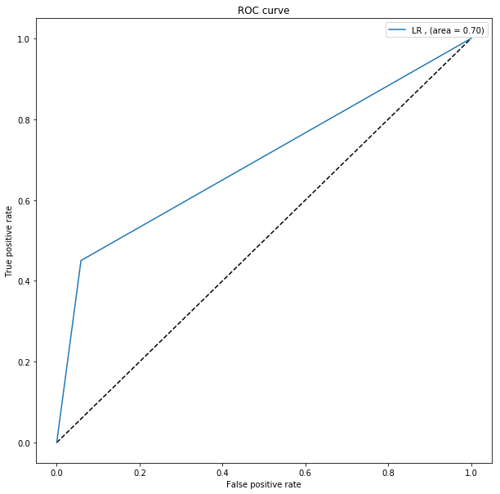We have to choose lambda carefully to avoid under fitting. The max iteration allowed is 1000 .

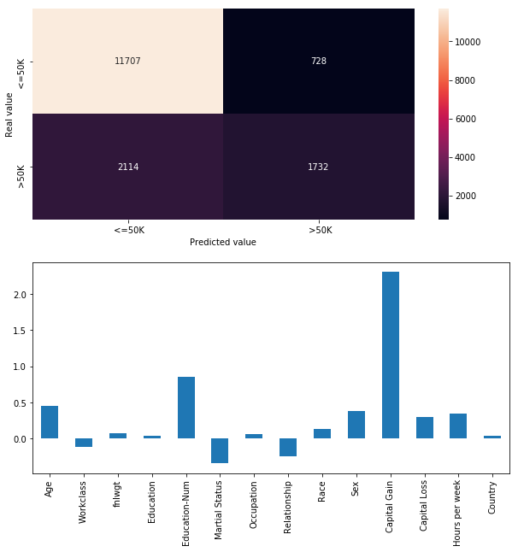

Figure 4. Showing the confusion matrix and coefficients on LEFT and ROC curve on the Right.

As can be seen in the figure 1. The heatmap shows the confusion matrix of the classification and the bar graph shows the coefficient of each feature.

Below is a detailed table of the parameters and performance values

|  |  |  |  |  |  |
| --- | --- | --- | --- | --- | --- |
| Logistic Regression | | | | | Interpretation |
| Feature select & balance  Performance  With binary classifier | ACC | 82.50% | TP | 1732 | In Logistic Regression method reduce feature decrease the predict accuracy, and balance is also unnecessary,  Overall, this method is good, it has a high accuracy in negative data and perform ok in positive site, and the ROC is high (0.8). |
| AUC | 0.69 | TN | 11707 |
| F1 score | 0.54 | FP | 728 |
|  |  | FN | 2114 |

1. The logistic regression can be enhanced by using ***Random Trees Embedding[1].*** In this method I split the training and test set twice because for fitting the data in random trees embedding, we cannot use the same training and testing set. After fitting the data through the random tree generator with depth of 3 and 10 estimators, I used a pipeline function to fit the random trees into my logistic regression with the leftover data.

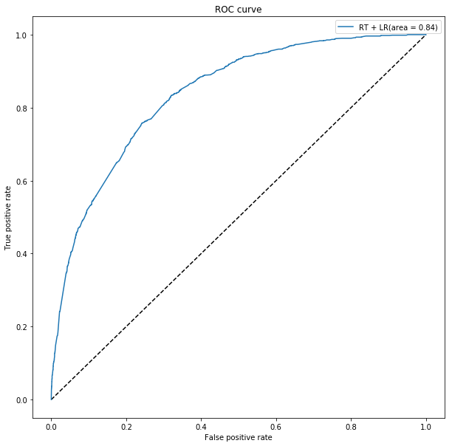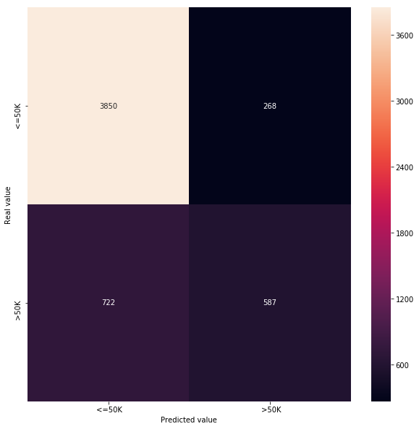This would take the data from lower dimensions to higher dimensions to create a classifier. Therefore, we can achieve a way better ROC curve as a result.

Figure 5. Showing the confusion matrix and coefficients on LEFT and ROC curve on the Right.

|  |  |  |  |  |  |
| --- | --- | --- | --- | --- | --- |
| Logistic Regression With Random Trees Embedded | | | | | Interpretation |
| Feature select & balance  Performance  With binary classifier | ACC | 81.90% | TP | 587 | Logistic Regression With random Embedded tree shows to be a very good classifier for our data since ROC curve for this classifier has a larger area than just logistic regression. This is an ***unsupervised*** way of classifying data using pipelines. |
| AUC | 0.84 | TN | 3850 |
| F1 score | 0.54 | FP | 268 |
|  |  | FN | 722 |

The dataset used to evaluate this classifier is obviously smaller because a portion of the data was used to create a random embedded tree.

1. Furthermore, the Logistic Regression can be improved by using ***Random Fores***t[1] classifier. This is done in my code using supervised techniques. Unlike other classifications I used one hot encoding for this classifier to handle the distributed categorical data better. The Max Depth was set to 3 and number of estimators are 10.

This method would also create a higher dimensional data of the features to create a better classifier from logistic regression.

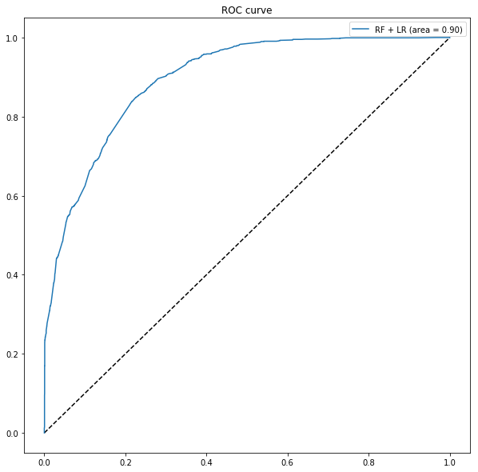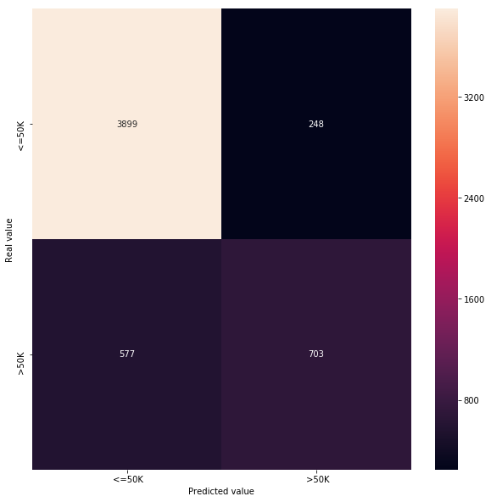

Figure 5. Showing the confusion matrix and coefficients on LEFT and ROC curve on the Right.

|  |  |  |  |  |  |
| --- | --- | --- | --- | --- | --- |
| Logistic Regression With Random Forest | | | | | Interpretation |
| Feature select & balance  Performance  With binary classifier  And one hot encoding. | ACC | 84.5% | TP | 703 | Logistic Regression with Random Forest shows to be a very good classifier with the highest ROC curve using logistic regression. This is a ***supervised*** way of classifying data. |
| AUC | 0.9 | TN | 3899 |
| F1 score | 0.63 | FP | 248 |
|  |  | FN | 577 |

1. I further explored the classification techniques. I next used ***perceptron classifier[2]*** to achieve better classification. We explored the perceptron classification in depth in class. 16281 data points were used to test.

$$\underline{w}\left(i+1\right)=\left\{\begin{aligned}\underline{w}\left(i\right)+ηZ_{n}\underline{X_{n}}, if{\underline{w}}^{T}Z_{n}\underline{X_{n}}≤0 \\ \underline{w}\left(i\right), if{\underline{w}}^{T}Z_{n}\underline{X_{n}}>0\end{aligned}\right.$$

In this classification method the weight of each discriminant function is determined by iterating through each feature. If the criterion function returned a negative or zero weight vector, then the next weigh vector would be replaced 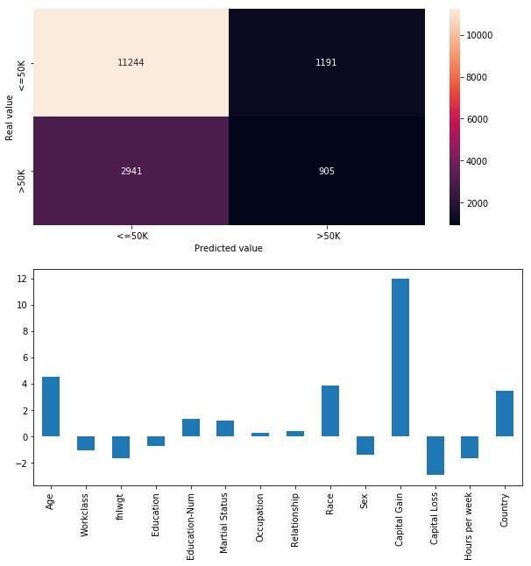with the current one and the iteration proceeds.

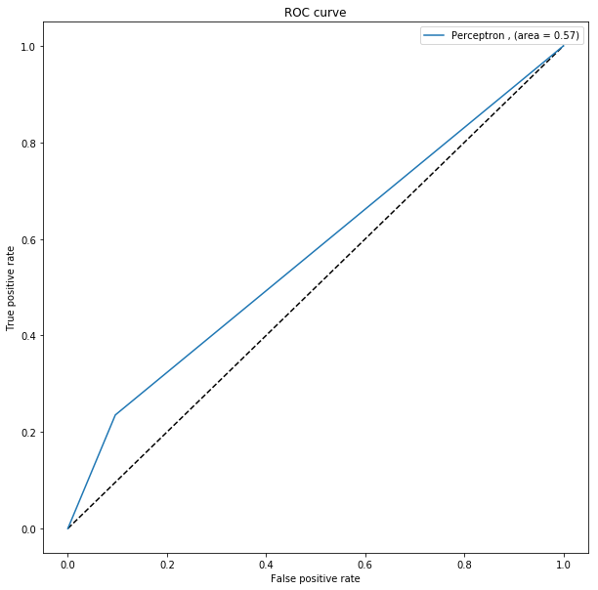

Figure 6. Showing the confusion matrix and coefficients on LEFT and ROC curve on the Right for Perceptron Classifier.

|  |  |  |  |  |  |
| --- | --- | --- | --- | --- | --- |
| Perceptron Classifier | | | | | Interpretation |
| Feature select & balance  Performance  With binary classifier. Using the big test set. | ACC | 74% | TP | 905 | The results show that Perceptron by itself is not a really good way of classifying the data. With a very poor F1 score and ROC area this is not a reliable classifier. |
| AUC | 0.57 | TN | 11244 |
| F1 score | 0.3 | FP | 1191 |
|  |  | FN | 2941 |

1. The perceptron classifiers are a found mostly used in ***Artificial Neural Networks[2].*** As next step I explored using Perceptron as a function in a multilayer neural network with feed forward. In this method I used a 15 by 2 layers of ANN.

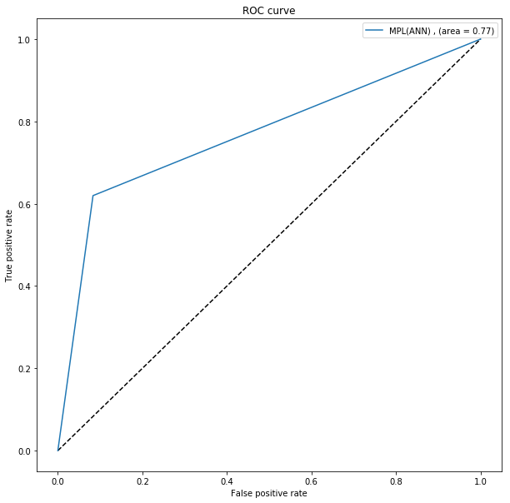For my Multi-Layer perceptron (MLP), I used ‘lbfgs’ which is an optimizer in the family of quasi-Newton methods. The Alpha should be carefully chosen because it gives different classifier shapes (discriminant function). It also works in **Augmented space.**

Figure 7. Showing the confusion matrix and coefficients on LEFT and ROC curve on the Right for Perceptron Classifier.

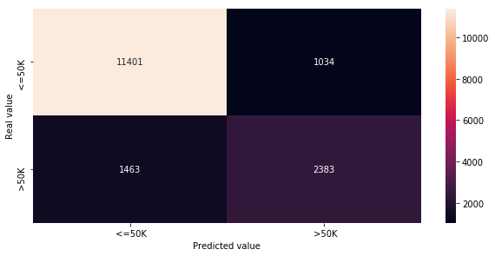

|  |  |  |  |  |  |
| --- | --- | --- | --- | --- | --- |
| Multi-Layer Perceptron Clasifier | | | | | Interpretation |
| Feature select & balance  Performance  With binary classifier. Using the big test set. | ACC | 84% | TP | 2383 | The results show that MLP is a good Way to classify the Data. It provides a good ROC area and also a good F1 score. |
| AUC | 0.76 | TN | 11401 |
| F1 score | 0.65 | FP | 1034 |
|  |  | FN | 1463 |

1. For this section I have tried multiple classifiers that I will show in tables. For the sake of length of the report I would not show the plots. I used KNN, SVM with sigmoid and RBF and multinomial naïve Bayes.

|  |  |  |  |  |  |
| --- | --- | --- | --- | --- | --- |
| Support Vector Machine with rbf as Kernel Function | | | | | Interpretation |
| Feature select & balance  Performance  With binary classifier. Using the big test set. | ACC | 76% | TP | 566 | This is a very poor classifier for our data set. Support Vector machines are application specific and they don’t seem to work well here. The are of ROC curve On this Classifier (AUC) is very close to 0.5 which is not useful. |
| AUC | 0.55 | TN | 11958 |
| F1 score | 0.23 | FP | 477 |
|  |  | FN | 3280 |

|  |  |  |  |  |  |
| --- | --- | --- | --- | --- | --- |
| Support Vector Machine with sigmoid as Kernel Function | | | | | Interpretation |
| Feature select & balance  Performance  With binary classifier. Using the big test set. | ACC | 70% | TP | 1376 | Once again Support Vector Machine Algorithm Doesn’t seem to be the best classifier. |
| AUC | 0.58 | TN | 10048 |
| F1 score | 0.36 | FP | 2387 |
|  |  | FN | 2470 |

|  |  |  |  |  |  |
| --- | --- | --- | --- | --- | --- |
| Naïve Bayes Classifier | | | | | Interpretation |
| Feature select & balance  Performance  With binary classifier. Using the big test set. | ACC | 78% | TP | 889 | Naïve Bayes Classifier has a very low ROC are and a poor f1 score. This is not a good classifier for our data. |
| AUC | 0.69 | TN | 11902 |
| F1 score | 0.33 | FP | 533 |
|  |  | FN | 2957 |

|  |  |  |  |  |  |
| --- | --- | --- | --- | --- | --- |
| KNN Classifier (3 Nearest neighbor was used) | | | | | Interpretation |
| Feature select & balance  Performance  With binary classifier. Using the big test set. | ACC | 81% | TP | 2383 | K nearest neighbor classifier is not a very bad classifier however compare to other classifier in the previous section it. The AUC score is still low |
| AUC | 0.73 | TN | 11401 |
| F1 score | 0.59 | FP | 1034 |
|  |  | FN | 1463 |

# Comparison, Results, and Interpretation

******Comparing the results of the tables the best classifiers for our data is the logistic regression with dimension expansion of random forest with f1 score of 0.61 AUC of 0.9 and Accuracy of 86%. The rest of the comparisons are made in the interpretation part of the tables.

# Contributions of each team member

I have Completed this project individually.

# Summary and conclusions

Consequently, I believe to classify any data, many preprocessing steps needs to be taken to come up with the best classifiers. Firstly, one needs to check, by plotting, how the features and classes are related. I checked if the data can be linearly separated. Secondly, I reduced the feature space by finding the correlation of the features with each other. Eventually to improve the performance of the classifier I Used random forest tree expansion to take the data to higher dimension.

Each sample goes through the decisions of each tree of the ensemble and ends up in one leaf per tree. The sample is encoded by setting feature values for these leaves to 1 and the other feature values to 0. The resulting transformer has then learned a supervised, sparse, high-dimensional categorical embedding of the data.

# References

[1]. " Feature transformation using ensemble of trees" Accessed: April 25 2019. <https://scikit-learn.org/stable/auto_examples/ensemble/plot_feature_transformation.html#sphx-glr-auto-examples-ensemble-plot-feature-transformation-py>

[2]. "Nueral Network Models" Accessed: April 24 2019. <https://scikit-learn.org/stable/modules/neural_networks_supervised.html>

[3]. " **L1 and L2 Regularization Methods**". Accessed: April 24 2019. <https://towardsdatascience.com/l1-and-l2-regularization-methods-ce25e7fc831c>

[4]. "AUC and ROC". Accessed: April 23 2019. <https://towardsdatascience.com/understanding-auc-roc-curve-68b2303cc9c5>

[5]. "Valentine Mihiv Blog" Accessed: April 10 2019. <https://www.valentinmihov.com/2015/04/17/adult-income-data-set/>

[6]. "Dealing With Imbalanced Data". <https://towardsdatascience.com/methods-for-dealing-with-imbalanced-data-5b761be45a18>

[7]. "Receiver Operating Characteristic".<https://scikit-learn.org/stable/auto_examples/model_selection/plot_roc.html>

[8]. "Lecture 10: Memoryless random variables and low-diameter partitions ".<https://homes.cs.washington.edu/~jrl/teaching/cse525wi15/lectures/lecture10.pdf>